**CPS 2231**

*Lab 6 – Abstract Class and Interface and Recursion*

**Instructions**

**Please note:**

**● There are 2 tasks in this lab.**

**● Follow the instructions to finish them.**

**Submission guidelines:**

**Task 1 (Gradescope)**

● Using the **SAMPLE FILES PROVIDED**, create a set of functional Java classes to complete the lab, according to the instructions provided below.

● **DO NOT MODIFY THE EXISTING CODE** in the sample files; you may **ONLY ADD CODE** to them.

**● DO NOT RENAME THE SAMPLE FILES.**

● Submit **ALL** of the following files (i.e., the files included as sample code) to the **GRADESCOPE** assignment titled **(TASK 1) Lab 6 – Abstract Class and Interface and Recursion**:

**○ Solvable.java**

**○ Problem.java**

**○ CodingProblem.java**

**○ MathProblem.java**

● Review the feedback (test case results) of your code in Gradescope.

**Task 2 (Canvas)**

● Write down your answers in a Word/Google Docs document.

● Convert it to a pdf file.

● Submit the pdf file to the assignment in CANVAS titled **(TASK 2) Lab 6 – Abstract Class and Interface and Recursion**

**Task 1: Abstract Class and Interface**

An Inheritance principle is used to explore and implement the ***Solvable*** interface below and the classes implementing it. The ***UML*** diagram of the inheritance hierarchy is represented below: 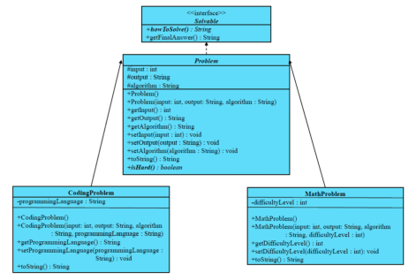

***Part 1.1***. Implement the *Solvable* inheritance structure strictly according to its UML diagram. Add comments stating where data fields, constructors, toString(), and other methods are (if any). **Neither method should have an empty body unless abstract methods.**

**Note: You should implement the *Solvable interface, abstract class Problem, regular class CodingProblem, and regular class MathProblem****.*

**1. *Solvable interface Problem***

a. Two abstract methods:

i. String **howToSolve()**

ii. String **inoi**

**2. *Abstract class Problem:***

a. Two constructors:

i. default constructor

ii. constructor with all fields

b. getters and setters for all fields

c. **toString()** method:

i. Note: modify by yourself to match the example output

d. Abstract method **isHard()**

**3. *CodingProblem class:***

a. One additional field

i. String ***programmingLanguage***

b. Two constructors

i. default constructor

ii. constructor with all fields

1. including ***programmingLanguage*** and the fields in the superclass ***Problem***

c. getters and setters for ***programmingLanguage***

d. **toString()** method:

i. Note: modify by yourself to match the example output

e. Implement **isHard()**:

i. Note: always return true

f. Implement **howToSolve()**:

i. return a string: “Write a xxx program.”

1. xxx should be ***programmingLanguage.***

g. Implement **getFinalAnswer()**:

i. return a string: “Eureka!”

**4. *MathProblem class:***

a. One additional field:

i. int ***difficultyLevel.***

b. two constructors:

i. *default constructor*

ii. *constructor with all fields*

1. *including* ***difficultyLevel*** and the fields in the superclass ***Problem.*** c. getters and setters for ***difficultyLevel***

d. **toString()** method:

i. modify by yourself to match the example output e. Implement **isHard():**

i. if ***difficultyLevel*** > 50: return true

ii. else: return False

f. Implement **howToSolve()**:

i. return a string: “Multiply to itself.”

g. Implement **getFinalAnswer()**:

i. return a string: “Eureka!”

**Task 2: Recursion Tracing:**

**We have learned the binary search algorithm this semester, but we implement binary search using a while loop. In this exercise, we are going to see binary search implemented by recursion and trace the recursion.**

Tracing the Recursion. Observe the recursive solution provided below and answer the following questions:

1. Which line(s) of this program define(s) ***the base case*** of the **binary**()

method?

2. Which line(s) of this program include recursive call(s)?

3. Trace the recursion below.

a. **You must show the tracing step by step (write them down);**

**otherwise – little to no credit!**

4. At what step of your recursion tracing did you hit the base case?

5. What is the final output of this code?

